DAT-530-Final Project.

Priyanka Reddy

Southern New Hampshire University

**Introduction:**

Based on the Scenario context I should act as an outside consultant for a U.S.-based hospital. As a consultant, i must represent the data on vaccination statistics to the hospital. The main task is to develop a vaccination policy considering numerous factors like vaccination type, patients age, gender, etc., CDC provides the requires data which is publicly available. Using this data source, we need to provide interactive visualizations so that all audiences may use it.

According to the scenario the audience for the development of vaccination policy will be hospital management, healthcare workers interacting with families, lay public and the analysts at hospital. The overall message for each audience doesn’t change instead the representation of visualizations varies from each set of audiences. The representation should vary as each audience should understand the data differently but the overall message remains same.

The whole project involves in extracting the data, correlating the data with the existing data and present the visualizations of the data to the audiences, based on the vaccination statistics to help the US health organization to create an effective policy on vaccination. There are different audiences and they understand the context differently. The audience for the development of vaccination policy will be hospital management, healthcare workers interacting with families, lay public and the analysts at hospital. So, when we take individual audience, their knowledge on the context may be different when we compare with other people. These understanding levels may be for various reasons, like there might be difference in their education levels, There might be chances of understanding the terms, where some might understand and others face difficulty even though they know about the context, it might be even the cultural diversity as in their culture they might be using some terms for some context , so there might be difference in diversity level and sometimes their background will also cause the problem in understanding the context. So, we need to prepare presentations and visualizations differently for different audiences. It is important that before we try to extract data from the source we have to make sure we have planned for the needs of audiences, have a structure for the presentation, and we have planned for what data need to be extracted. So, in this mile stone I want to discuss more about the methods, platforms which I will be using for presenting the data to each audience. I will be discussing on each audience on how I am going to present the data, visualization to make understand about the vaccination policy of US hospital. The main goal of this project is to make understand audience of vaccination policy. So i will be explaining about the procedure i would like to follow.

**Audience Needs**

In this section I will discuss about all three audiences and their characteristics. Before considering audience, I will discuss on audience’s characteristics. The characteristics includes Gender, Age, Marital/ parental status, Income. For example, if we know all of our audiences are females the we can concentrate and prepare visuals kind of feminine than masculine. The age also matters while presenting as the teenagers grasp things easily as they will be aware of modern technology while people with age more than 65+ will have different mindset. So even age matters a lot. We should also get to know about their marital / parental status as single persons presentation things will be different when compared with married people. So even this status matters a lot in this context. Audiences income level tells us what audiences can afford and what not, so that we can prepare accordingly.

**Audiences**

Before representing any concept or data firstly we should get familiar with our audience. It is not necessary that every individual audience should understand the presentation. As there are many factors which must be considered before presenting the data. The hospital management might be familiar with the issue, the healthcare workers might be aware of the issue, whereas the lay public and some other analysts might not be familiar with issue or they might know little about the issue. The hospital management will be highly educated so they might understand the issue and ca grasp the data and understand the presentation quickly.

The healthcare workers are also educated so they may understand the issue and presentation easily. But Whereas the lay public there are again differentiation, there might be highly educated people, or lower when compared with hospitality management and the lay public will have greater variability. When we look into the age levels, the hospital management will be above average as all the officials will be experienced and higher in age, when compared to the lay public and the health care workers. The lay public and the health care workers include different age levels, there might be younger people, old people, teenagers, adults etc. The official language which is spoken and communicated is English. The hospital management can communicate and better understand English, whereas the lay people and healthcare workers there might be people from different diversities and people don’t understand English too. The cultural diversity is more in case of lay people any the healthcare workers than compared to the hospitality management. When we look at all above factors, we can understand that when we target audience all these factors play a crucial role in presenting the data to different audience.

When we want to present a single presentation, we must make sure that all targeted audiences understand the presentation with defining the terminology, basic concepts and all, so that the presentation can be understood by every targeted audiences. Whereas when we are presenting the different presentations based on audiences, the presentation and visualizations might vary based on different audience but the overall message of the context remains same.

The overall message for this case study and must deliver to audience is that How important the vaccinations for the people to keep them secure and health. When the vaccination policy is developing, we must make sure that all factors mentioned above are considered and considered which factors needs in collecting the vaccination data. When the policy is made, it must make sure that what data represent understood by all people and must get approved by the stakeholders of the hospital.

**Explanation of presentation methods**

The research question based on the prompt will be “What is the Vaccination policy of the hospital”. This question has to be solved by me as a analyst to present to various audience. And According to me the data that is provided is sufficient for solving the problem and provide solution and making visualizations. As mentioned in the prompt there are many tools available for creating the visualizations. Out of which QlikView and Excel power view are the better options in my opinion. Using QlikView it is easy to create the visualizations and represent differently for different audience. These tools help us in creating the bar charts, descriptions, making videos, making graphs and making the interactive dashboards for various audience.

The visualization which we create must be understood my targeted audience. For the hospital management, we need not to discuss from the basics. We can just start with elevated level representations and visuals without using any terminology and any description. As they have required knowledge about the issue. Whereas when we present to lay people and the health care workers, we need to provide with basic representation and we must define terminologies and provide detailed explanation for every concept and we have to explain every visualization we present. We have to present the scenario in many different forms like bar graph, pie chart tabular columns so that it can be understood by them. We have to define all the abbreviations. So the representation and methods has to be different for different audiences.

So In presenting different visualizations to the audience, we have to make sure all audience are aware of the issue and then we have to get support from the audience in order to promote the policy. In presenting the visualizations there should be different kind of representations in order to reach audience and make them to understand and aware of the issue and policy. Because the understanding level varies from hospital management, healthcare workers, laypeople and the analysts, etc., we have to develop the key messages which will be effective in order to speak to targeted audiences. As mentioned above the communication channels, techniques and tools varie for different audiences. We need to use different charts, graphs and description for different audience. And presenting all this presentation and the charts into documentation is another important thing while representing things to audiences. We should always consider the lay people first in presenting visualizations as the higher educated people can understand everything with minor explanations whereas the lay people will have vast combinations like half-knowledgeable, no idea about the issue, etc. While presenting any presentations we have to keep considering every individual.

**AUDIENCE- HOSPITAL MANAGEMENT**

The hospital management team can be considered as high-tech people, as they are well educated and they know about hospital management. The hospital management will have enough knowledge about the terminology and regarding the issue based on other factors that they are already considering. The Hospital management people like higher officials(Managers) who might be interacting with the other level of management like health care workers and other teams. So, these management people might be aware of the context. These management people must understand about the policy and the data as they have to understand how this policy will affect their job requirements.

As these people have knowledge of what vaccination is I don’t think I need to write any documented everything from basic like starting from what is vaccination policy, why it is used, how it is done for preventing some virus. So, we can just do document like when can they implement policy, who are all involved, what are their responsibilities and how they need to work towards the policy. In this case if all management people are together then it is better to present through power point presentation instead of providing a set of documents. As this would be easy to understand and if we provide any graph plots related to the vaccination I think that is more than sufficient. But if they are from various places then it is better to communicate via web blog where everything is posted. Power point will provide effective communication while discussing about policy as it is short writing and directly discuss about the point. So, power point is good medium for health management people. And when we want to represent in the form of plots, I would like to describe based on age and their risk factors, I would like to represent a pie chart in order to calculate the gender based chart to determine whether it is male or female. I would like to show various vaccinations happening now and which age group people are taking what. SO with this they can come to know which vaccinations are taken by whom and they can check which age group people are prone to more viruses, so that they can make better policies.

**AUDIENCE- Health Care Workers**

The health care workers team can be considered as low-tech people, the healthcare workers will have basic knowledge on how to put vaccination, who are taking vaccination but hey will not have any idea on vaccination, how does it work, what are it effects and side effects. Health Care workers will not have enough knowledge about the terminology and regarding the issue based on other factors that they are already considering. So, these health care people might be aware of the context but not fully. These health care workers people must understand about the policy and the data as they must understand how this policy will affect their job requirements.

When it comes to presentation medium I would like to present through proper documentation of defining all terminologies, providing graphics for each explanation, presenting simple graphs with detailed explanation, and I would also provide them videos on how this work. So, proper documentation will help some of the workers to study and providing each context with related picture will also help them to understand better and will also save time for them. And when coming to video I would say these days people are so fascinating towards technology. So, video help them to present effectively so that they understand with in no time and Dash boards also help them to understand bitterly if we provide them with all clear information and when the dash board is easy to use.

Initially, I want to present how people are taking different vaccination with bar graph. Then I would also represent the bar graph by separating male and female in each vaccination. I would also like to present based on years. I would like to present with simpler graphs with all details as a result it would be easy for them to represent what is what when they are interacting with the patient families.

**AUDIENCE-Lay People**

The lay people can be considered as no knowledge people, these lay people will have no idea on what is vaccination and why does we take it, most people just follow the procedures as it is recommended by their doctor or family. Lay people will not have enough knowledge about the terminology and regarding the issue based on other factors that they are already considering. So, these lay people are no way involved into vaccination policy. These lay people people must understand about the policy and the data as they must understand how this policy will affect their lives.

For lay people as i would like to use Videos, Pamphlets, and general advertisements to create awareness among people. For lay people, we need to present everything from definitions with examples and good pictures and graphs. So, pamphlets should be good idea while presenting everything into pictorial form, as this would reach them easily. Advertisements will also reach them quickly.

For lay people, I would like to present how people are taking different vaccination with bar graph. Then I would also represent the bar graph by separating male and female in each vaccination. I would also like to present based on years. I will also represent every year record and how people are prone to danger, and how vaccination helps them.

Finally, it is difficult to present visualization differently as each audience has individual set of thinking. But when we know about our audience it is easy to communicate and provide exact details and help them in understanding the policy. I will provide every visualization in the next mile stone on how I would provide graph for each individual.

**Determining A Visualization Strategy**

In this project, we can see various audiences and various group of people. These audiences must understand the context and data easily and clearly. To make audiences to help them understand the data, we must consider many factors like their education levels, age, gender, their background for the visualization strategy. By presenting the accurate visuals for the audience by maintain the appropriate colors, styles, interfaces, graphs followed by the formatting the guidelines. By following all the above rules, we can the make effective visuals for the audiences differently to make them understand better. I have described all the following rules below for different group of people.

**The Public**

The public is the people where they have nil knowledge about the context and the regarding the data. The public will have different age groups, public might be from diverse backgrounds, their education levels might be different, and their language might be different and usage of computers will depend on their education levels. So, for this group of people we need to present everything in simple and clear context. We must present basic visuals with bar charts where they can understand relate with the categorical data. To make the visuals appealing we must present graphs with bright colors with unique colors making simple graphics with lot more white space to make visuals effective. The titles presented on the graph should have the description as the public will be unaware of the terminologies and abbreviations of the short and abbreviated words. The graphs should be simple straight lines instead of the curves and mores clumsy bubble chart. By this way the public will not get distracted and confused. The interfaces should be user-friendly and must have a simple portfolio where all visualizations are included and related links must be provided. The abbreviations and terminologies also must be explained clearly. We should maintain the low granularity for the sake of public. We should also provide videos if necessary in order to make understand the data and importance of vaccination easily.

**Hospital Management**

The hospital management people are the people where they have knowledge about the context and the regarding the data. The hospital management group will have different age groups, from diverse backgrounds, their education levels might be different, and their language might be different and usage of computers will depend on their education levels. Even all factors varies but their knowledge on the data is same and they are more proficient. So, for this group of people we can use high end visuals with more graphics considering all variables together as these groups can analyze easily. We must present visuals with bar charts, combination charts, bubble charts, pie charts etc., where they can understand relate with the categorical data. To make the visuals appealing we must present graphs with bright colors with unique colors. We should always maintain unique colors for any visuals and for any group of people. The titles presented on the graph should have the description. But there is not necessary to present terminologies. The graphs should be simple straight lines, curves and mores clumsy bubble chart and combination without compromising and make visuals effective. By this way, the hospital management will not get distracted and confused. The interfaces should be user-friendly and must have a portfolio where all visualizations are included. The abbreviations and terminologies also must be explained. We should maintain the granularity for the management people. We should also provide videos if necessary to make understand the data and importance of vaccination easily. we should also present causes, side-effects, pros and cons of this vaccination policy.

**Health care workers**

The health care workers are the people where they have basic knowledge about the context and the regarding the data. The workers will have different age groups, public might be from diverse backgrounds, their education levels might be different, and their language might be different and usage of computers will depend on their education levels. This group will have little knowledge so, we need to treat this group equal to the public. So, for this group of people we need to present everything in simple and clear context. We must present basic visuals with bar charts where they can understand relate with the categorical data. To make the visuals appealing we must present graphs with bright colors with unique colors making simple graphics with lot more white space to make visuals effective. We can use combination graphs but we cannot use complex graphs as these workers will be distracted and confused. The titles presented on the graph should have the description as the workers will be unaware of all terminologies and abbreviations of the short and abbreviated words. The graphs should be simple straight lines and curves instead of clumsy bubble chart. By this way, the workers will not get distracted and confused. The interfaces should be user-friendly and must have a portfolio where all visualizations are included. The abbreviations and terminologies also must be explained clearly. We should maintain the low granularity for the sake of public. We should also provide videos if necessary to make understand the data and importance of vaccination easily. we should also mention of the purpose of this vaccination. And we should clearly mention their responsibilities to make them work effectively towards the purpose of this project.

**Feedback Mechanism:**

For any presentation, we present feedback is the crucial factor we need to consider. In this project, I used PowerPoint presentation for health management people. SO, I will be providing my email-id and contact number. For health care workers, I have made dashboards and also presented pamphlets so that they can reach out me for further information. For lay people I have made pamphlets so that they can contact me and also provided information regarding the us hospital and their vaccination policy.

**Hospital Management:**

For Hospital management, I have decided in previous milestone to make pie charts in order to discuss and make an analysis on patients age and their corresponding risks and I also made an chart based on each vaccination how many people are getting treated and I even want to analyze how many males and females are being treated every year on a particular single vaccination. The first image represents how many males are there and how many females and in the next followed images I took only male gender and to see which age group is taking vaccination at what percentage.

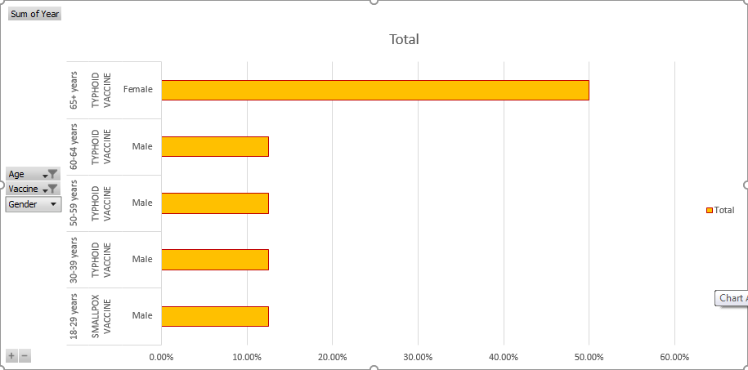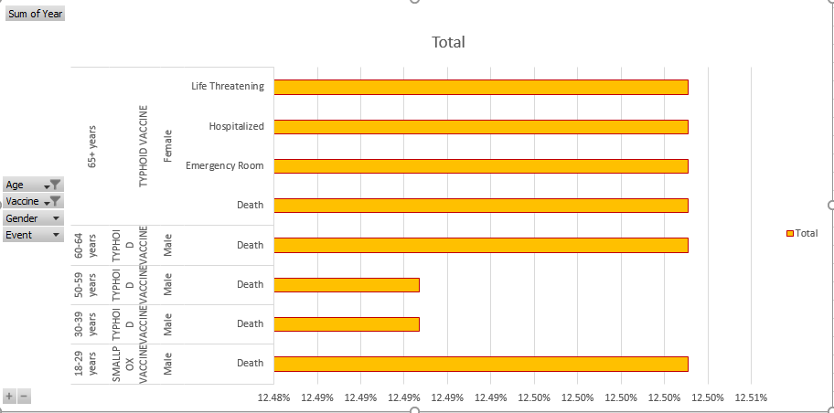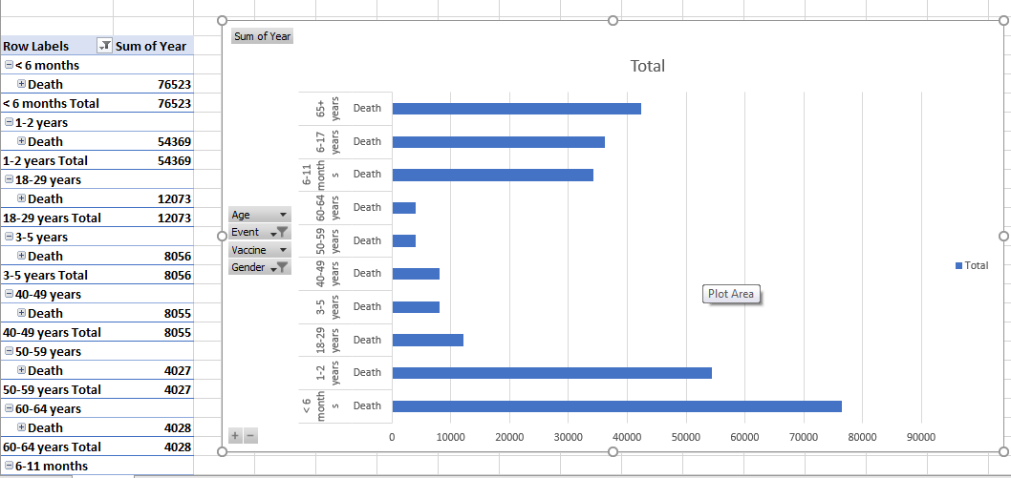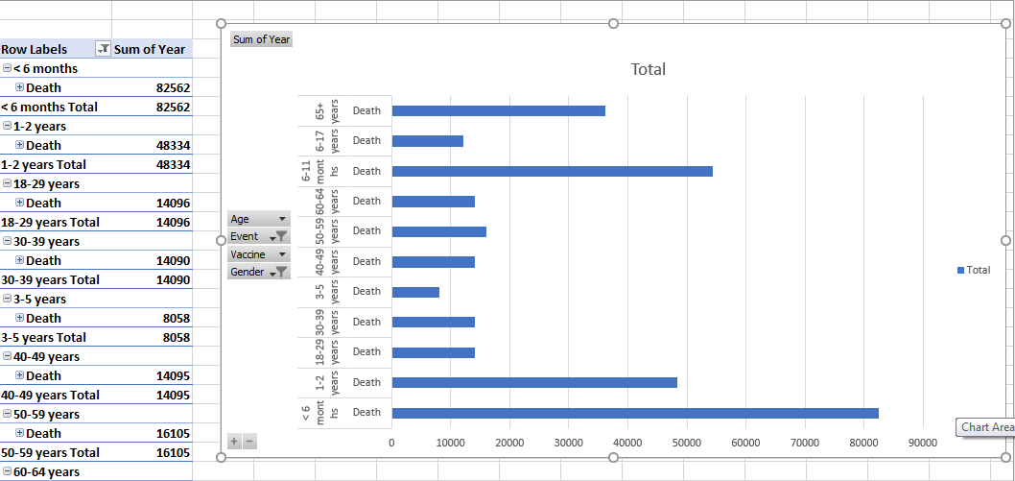

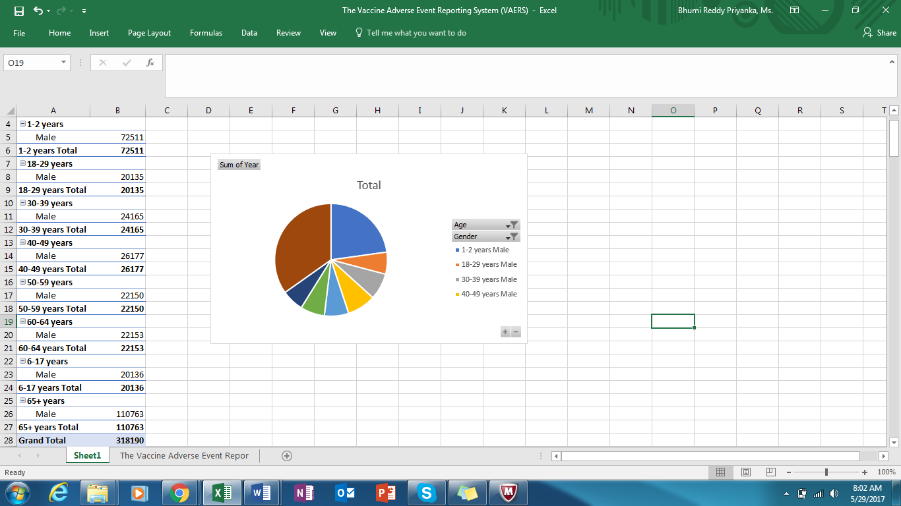

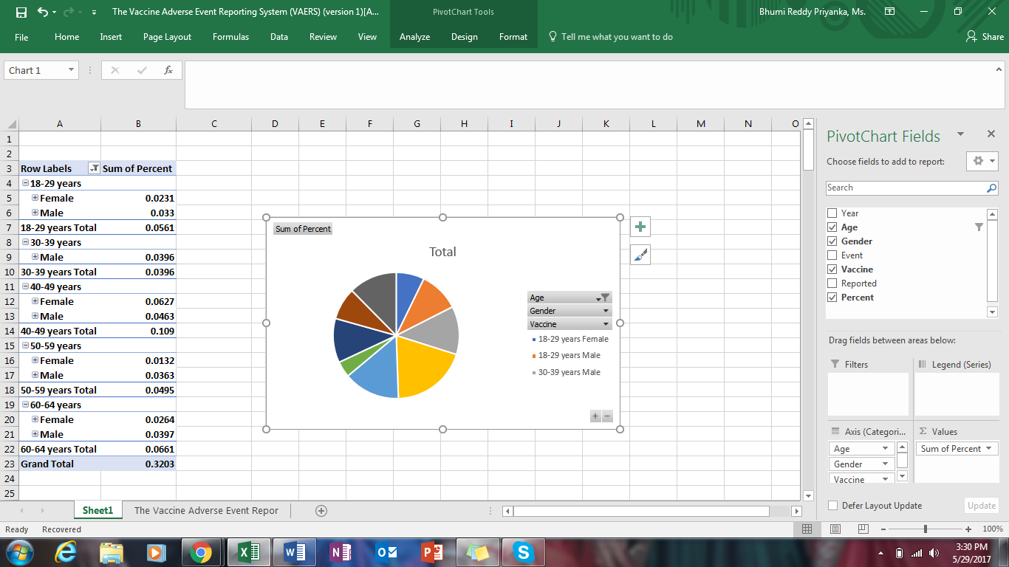



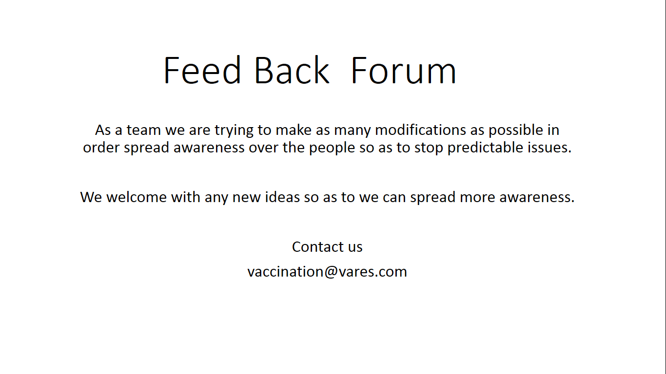

**Health Care Workers**

The Below plot shows the number of adverse reactions by age group. For the sake of Health care workers and Lay people I wanted to present everything from basics so I have created a dash board which represents which age group need more vaccinations, based on gender group I made a graph of even occurred without vaccination and how many adversely reacted by age group. I wanted to present these visuals so as to make health workers and lay people understand every year how many people are dying because they didn’t take vaccination and varied by age group. This visual helps them to understand what vaccinations are available and what happens when people doesn’t take vaccinations and which age group need more vaccinations. I also want to make a documentation so as to describe more details about what is vaccination, and about each vaccination, and how this helps people to overcome more prone issues related to health. I make a video for making these people understand of what is what.

For Feedback session, I ask people to attend seminars and workshops and there I ask people to provide suggestions and also feedback from people so as to improve our presentation so that we can reach people very easily. I will provide them a pamphlet mentioning address and phone number, mail-id of the development research team. The details will be as follows.

Seminar-1: Theater-301, xyz street, xyz county, xyz state-03xxx

Contact: [vaccination@vares.com](mailto:vaccination@vares.com)

Phone: 1-800-xxx-xxxx

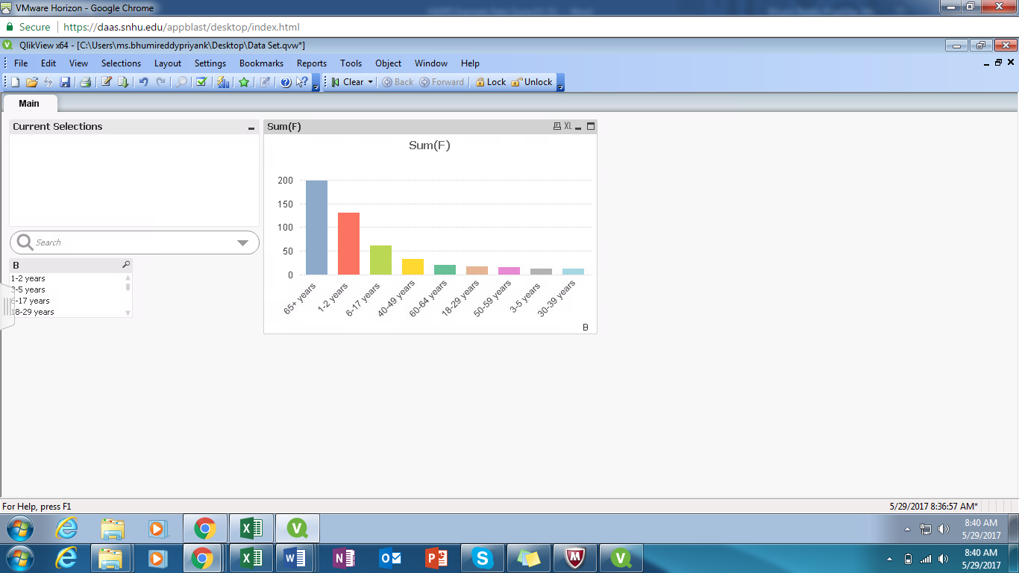

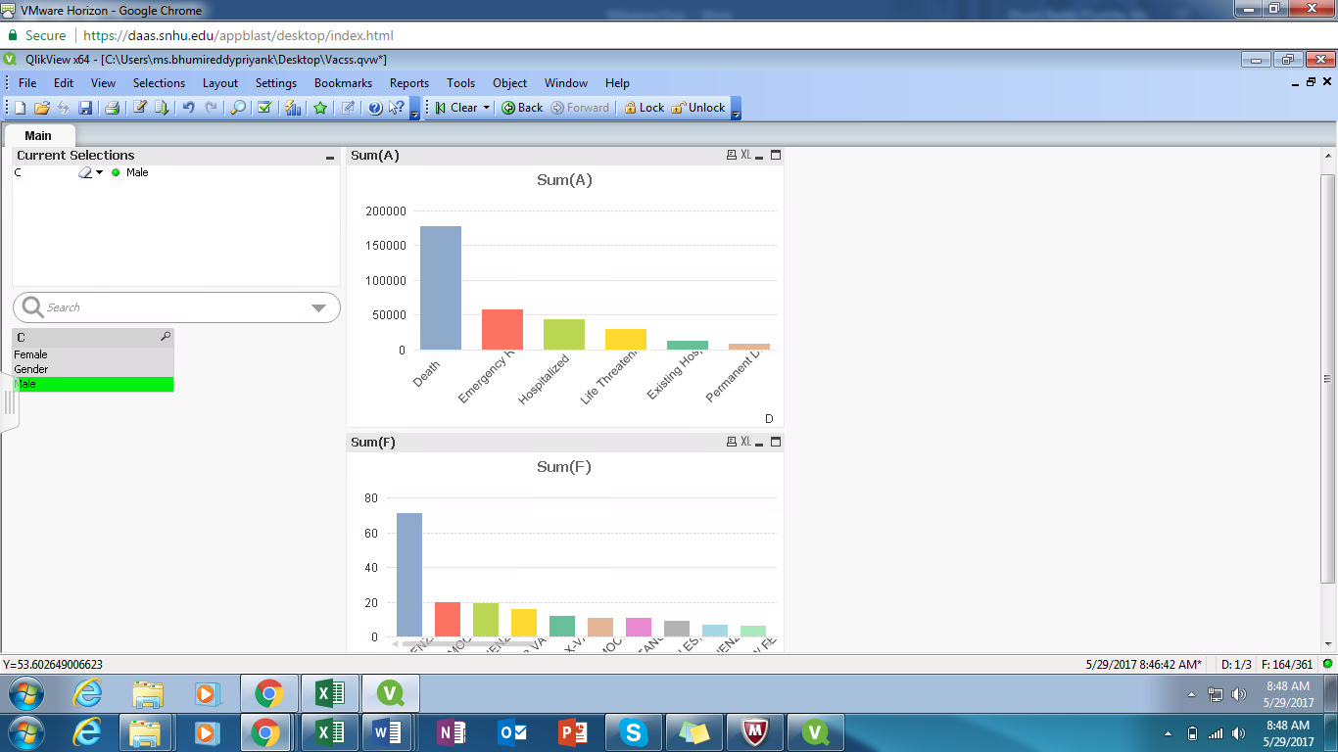

**Lay people**

The Below plot shows the number of adverse reactions by age group. For the sake of Lay people, I wanted to present everything from basics so I have created a dash board which represents which age group need more vaccinations, based on gender group I made a graph of even occurred without vaccination and how many adversely reacted by age group. I wanted to present these visuals so as to make lay people understand every year how many people are dying because they didn’t take vaccination and varied by age group. This visual helps them to understand what vaccinations are available and what happens when people doesn’t take vaccinations and which age group need more vaccinations. I also want to make a documentation so as to describe more details about what is vaccination, and about each vaccination, and how this helps people to overcome more prone issues related to health.

For Feedback session, I ask people to attend seminars and workshops and there I ask people to provide suggestions and also feedback from people so as to improve our presentation so that we can reach people very easily. I will provide them a pamphlet mentioning address and phone number, mail-id of the development research team.

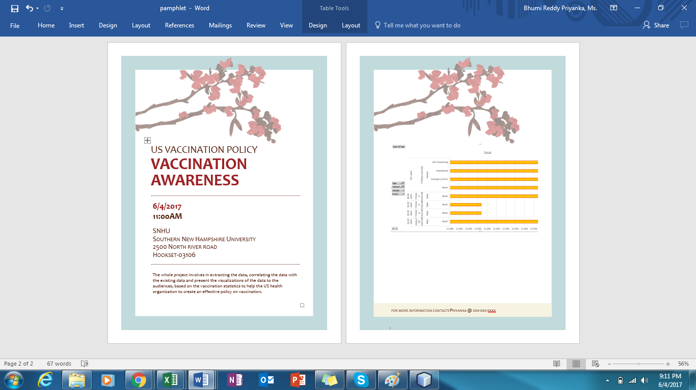

<pamphlet.docx>



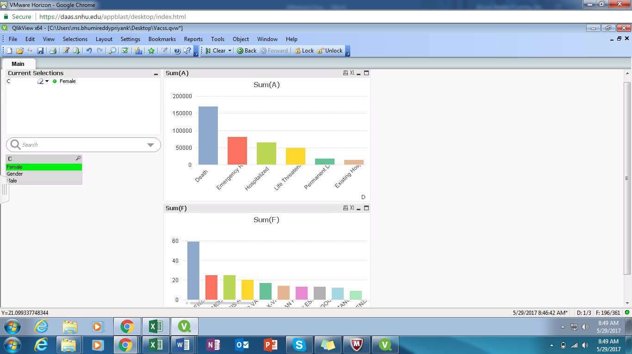

**Conclusion**

Even after presenting differently for all diverse groups but the overall message of spreading message about the vaccination. Even though we use different visuals for diverse groups but the overall message will not change. we need to covey the final message to all equally. But there will be job responsibilities for hospital management and health care workers.

# References

*Center for diease and its prevention*. (n.d.). Retrieved from wonder.cdc.gov: https://wonder.cdc.gov/vaers.html

Hunter, G. (2016, August 11). *WHAT VISUAL COMMUNICATION MEANS IN HEALTHCARE*. Retrieved from manageupprm: https://www.manageupprm.com/blog/2016/11/8/what-visual-communication-means-in-healthcare